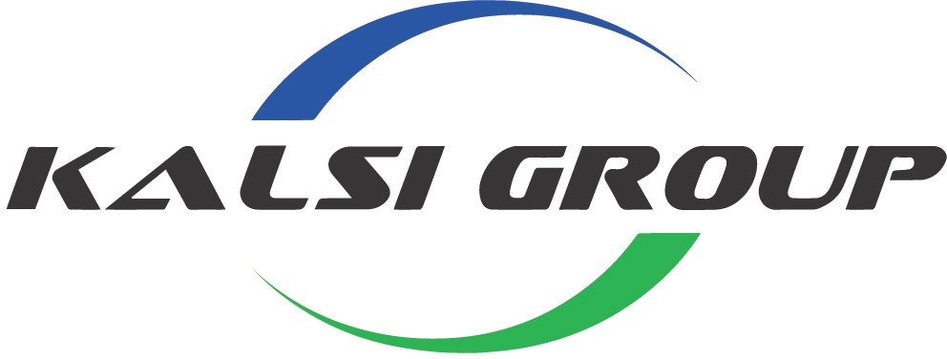
Kalsi Plastics Gender Pay Gap Reporting 2021

Background
Kalsi Plastics (UK) Ltd have undertaken analysis on the average earnings and bonuses for male and female employees as required by the Equality Act 2010 (Gender Pay Gap Information) Regulations 2017.
Although this is a compulsory requirement for the company, Kalsi Plastics (UK) Ltd are happy to comply as we are always looking for ways to improve in terms of business results and job satisfaction.

Results

Mean, Median and Bonus Proportions

Our mean gender pay gap is 13.91%, whilst the median gender pay gap is 2.84%.

Our mean gender bonus gap is 100% and median gender bonus pay gap is 100%

The proportion of males who received a bonus is 10.28%. The proportion of females who received a bonus is 0%.

Pay Quartiles

Upper Quartile – Male 93.65% and Female 6.35%

Upper Middle Quartile – Male 95.24% and Female 4.76%

Lower Middle Quartile – Male 95.24% and Female 4.76%

Lower Quartile – Male 89.06% and Female 10.94%

Kalsi Plastics (UK) Ltd maintains a fair and balanced approach to determining pay for all employees where gender is not taken into consideration. We will continue to appraise our processes to ensure this approach continues in our future policies for all employees.
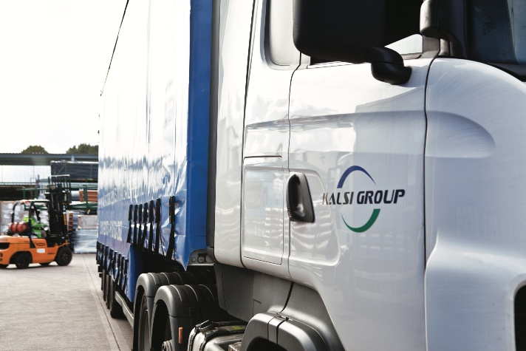
Mr HS Kalsi Company Director

